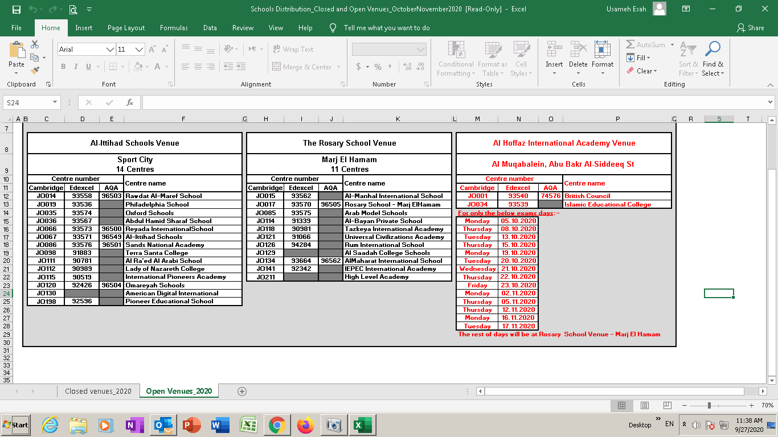

AL-ITTIHAD SCHOOLS VENUE
FOR OCTOBER- NOVEMBER 2020
CAMBRIDGE AND EDEXCEL EXAMINATIONS

